Please contact the Urich Cemetery Association if you have further questions.
If you are unable to make contact with the Cemetery Board, call City Hall at 660-638-4813.

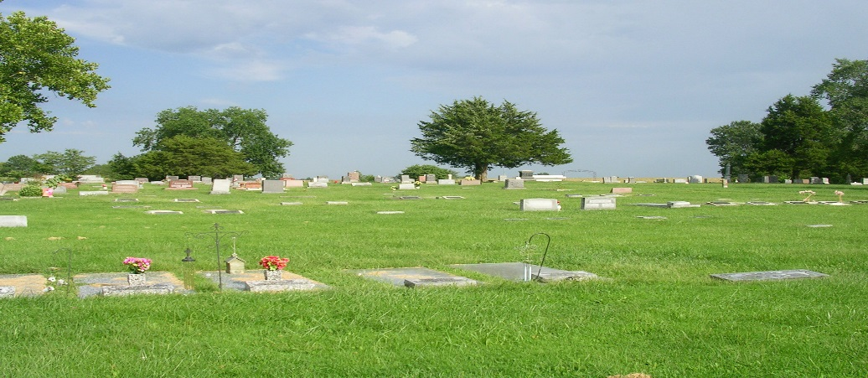
Driving directions from Urich:
State Hwy B North to NW 1271 Road (1st Road to the East after the Urich overpass). Turn right (east) onto NW 1271 Road. The road will turn back to the left (north) and state maintenance will end, continue on gravel. At the intersection (or “T”) turn left (west) continuing on gravel, the road will curve back to the right (north). The Cemetery is on the west side of the road about a quarter of a mile.
urich cemetery
NW 1271 Road
Urich, MO 64788
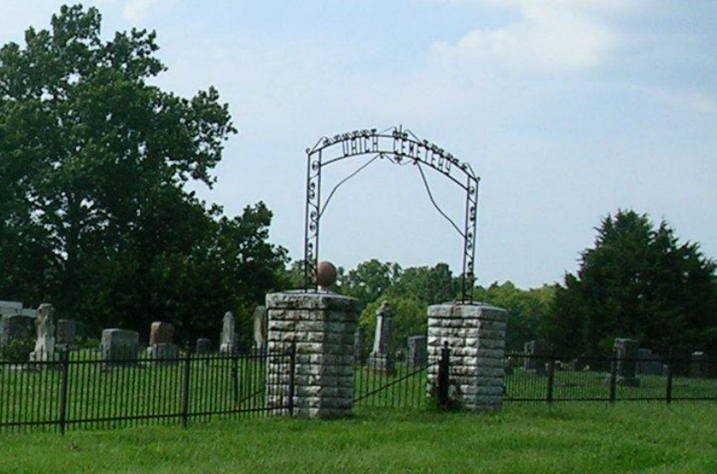
Founded 1891
2023-24 Board Members:
President, Glen Stewart Phone #601-351-1209
751 NW 1531st Road, Urich, MO 64788
Vice President, David Vogt Phone #816-810-0676
1049 NW 1151st Road, Urich, MO 64788
Treasurer, Deidra Leonard Phone #660-909-4868
Secretary, Stacy Stewart

Basic information
Several area residents began donating parcels of land to the City of Urich for cemetery purposes as far back at February 1891. The Urich Cemetery Association is registered and recognized by the State of Missouri and the City of Urich as the caretaker of property and finances for the Urich Cemetery.
The Original By-Laws are as follows (*-Denotes an update):

- *The Urich Cemetery Association shall meet the first Tuesday of each month beginning with March and ending with October.
- The Executive Committee shall consist of President, Vice-President, Secretary and Treasurer.
- *Anyone is eligible to membership in the Association who will work with the Association for the up-keep of Urich Cemetery, but to vote on matters of business they must be owner or part-owner and supporter of a lot in Urich Cemetery.
- The President shall appoint each year a Ground Committee, Labor Committee, Repair Committee, Purchasing Committee, Chairman of Membership Committee, and any other committees as are needed from time to time.
- The Association shall keep valid a motion that was passed and spread upon its minutes November 6, 1937, relative to the up-keep of all lots that are provided for by long time deposits.
- The association shall make a public statement of its assets and expenses following the last regular meeting of each year.
- Any one of these By-Laws may be changed only by vote of three-fourths of the membership, provided this change does not conflict with the Charter.
- The sum of $1,000.00 invested October 1943, in G Series of U.S. Bonds shall be held as a basic support, for our Cemetery Association. Pledges of continual care on lots and part lots, as recorded in the Cemetery Association Books will be held for basic support as well.
- *No trees or plants may be planted in the Cemetery.
- Wooden boxes will no longer be used for burial.
- *Fourteen days after Memorial Day all decorations left on graves shall be disposed of by the Association.

Rules & Policies Updated ~
- No trees, bushes, shrubs, flowers or vegetation of any kind may be plated in the cemetery except grass.
- Flowers are to be removed within two weeks placement.
- Any type of commercially made headstone is allowed. Fieldstone or homemade markers are not allowed and will be removed.
- It is customary to have the husband buried on the north side of his wife; however this is not a regulation. It is at the individuals’ discretion.
- Any unresolved questions about title to a grave site are to be referred to the Cemetery Association for arbitration.
- Anyone owning an interest in a lot in the Urich Cemetery and who wishes to be involved in the operations of the Cemetery Association may become a member of the Association by attending the Association’s meetings and expressing that desire.
- Regular meetings are held on the third Friday of each month, excluding the winter months. Please contact a member listed for the next meeting date.
- The annual Meeting is held on the third Friday in October at 7:00 pm at the Urich City Hall, 308 Main St., Urich, MO

Responsibilities other than the Cemetery Association:
- 06/10/2008-Burial Sites are sold in pairs only at a cost of $500.00. This includes the cost of burial sites at $125.00 each and the endowment of $125.00 each.
- Lots may be purchased at Urich City Hall during regular business hours.
- Grave location is the responsibility of the City of Urich for the physical location of the grave and updating and maintaining the burial records for the Cemetery Association. A fee of $50.00 is charged for this service. Normally, this is done through the Funeral Home.
- The fee charged for the actual opening of the grave is normally done through the Funeral Home.
- The Urich Cemetery Association and the City of Urich recommend that “Cemetery Deeds” be filed at the Henry County Courthouse for permanent documentation. This is at the owner’s expense.
- Cremation is considered a burial, applicable fees will apply.
- Grave markers are not the responsibility of the Cemetery Association or the City.

